MOLDOVA STATE UNIVERSITY
FACULTY OF MATHEMATICS AND COMPUTER SCIENCE
DEPARTMENT OF COMPUTER SCIENCE

Laboratory Work №1
Discipline: Artificial Inteligence in Game Engine
Topic: "Designing NPC Behavior Using a Finite State Machine"

Instructor: Treticova Elizaveta
Student: Ciochina Eric
Group: DJ2503

Game map description
The game scene consists of an enclosed, square-shaped arena featuring a multi-level landscape. Key map characteristics include:
• Surface: A NavMesh is used for AI enemy navigation, allowing them to move freely across the entire map.
• Obstacles: Wooden barriers and concrete structures are placed throughout the map, serving as cover and complicating navigation.
• Architecture: The map features various elevations and depressions, creating a three-dimensional landscape for tactical gameplay.
• Light Sources: A Directional Light provides global scene illumination, while a Global Volume handles post-processing.
• Element Hierarchy: The scene includes the Main Camera, the player, two hostile NPCs (180 Enemy and Teleport Enemy), and patrol points (points 1–15).
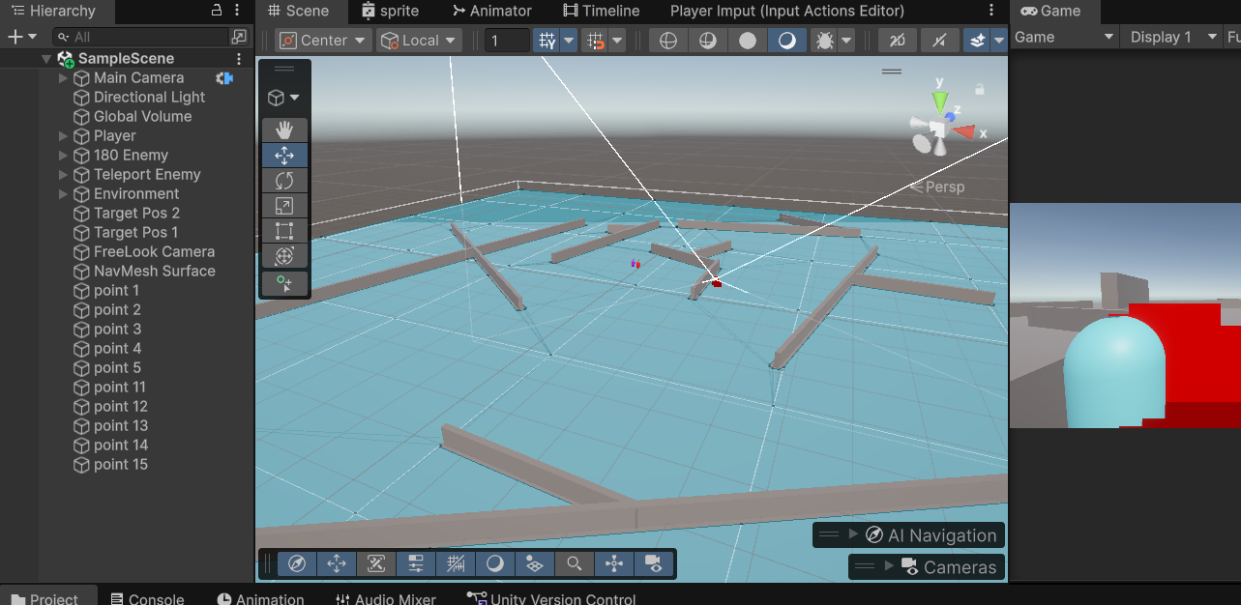

Player Functionality
The player character is controlled via a Character Controller and uses the following components:

Player_Movement script
Handles character movement and control. Key parameters:
• Walking speed: 5 m/s (Speed)
• Sprinting speed: 10 m/s (SprintSpeed)
• Maximum stamina: 100 units
• Stamina consumption while sprinting: 7 units/sec (StaminaDrain)
• Stamina regeneration: 3 units/sec (StaminaRegeneration)
Control mechanics:
• Input: Uses the new Input System to read Move and Sprint actions
• Movement: Character moves relative to the camera's facing direction (forward/right vector)
• Rotation: Smooth rotation (Lerp) towards the camera direction with a smoothing factor of 0.1
• Gravity: Gravity (-9.8) is applied for character falling
• Stamina: Stamina is consumed while sprinting and regenerates when idle or walking

Player_Health Script
Manages the player character's health:
• Maximum health: 100 units
• Damage from enemies: 10 units per attack
• Effects: A Particle System (20 particles) activates upon taking damage
• Game over: Exits Play mode when health is ≤ 0 (EditorApplication.ExitPlaymode)

Integration with Cinemachine
The camera uses Cinemachine to smoothly follow the player. Its rotation is linked to the `movementDirectionObject`, which is determined by the camera's position (the Virtual Camera tracks the player and orients itself based on the direction of view).
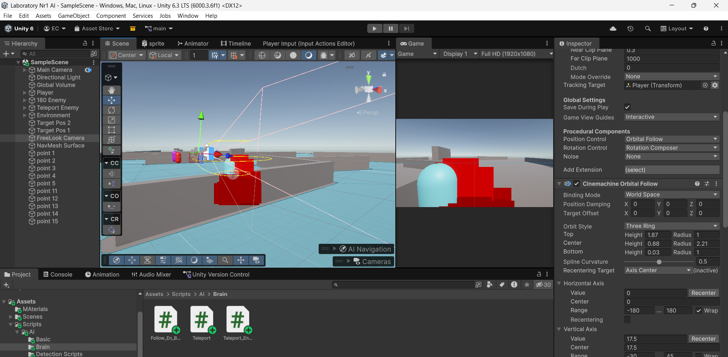

Hostile NPC mechanics

"Follow" type enemy (Follow_En_Behaviour)
The first type of enemy employs a pursuit behavior with a limited field of view. It is a less advanced enemy featuring a focused detection system.
Detection Mechanics:
• Method: Raycasting (50 rays)
• Field of View: 180° (hemisphere in front of the enemy)
• Range: 20 units
• Result: Upon detecting the player on the 'Player' layer, the enemy switches to Chase mode.
State Machine:
• Idle: Duration of 3 seconds, followed by a transition to Patrol.
• Patrol: The enemy follows 5 patrol points (patrolPoints[0-4]). Upon reaching a point, it moves to the next one. If the player is detected -> Chase.
• Chase: The enemy heads toward the player's last known position (lastPlayerPosition). If distance < 1.3m -> Attack. If the player is not detected -> Search.
• Attack: The enemy attacks the player at 2-second intervals (attackCooldown), dealing 10 damage. If the player moves out of attack range (> 1.3m) -> Chase or Search.
• Search: The enemy waits in place for 2 seconds (searchTime), attempting to re-detect the player. If detected -> Chase; otherwise -> Idle.
Components:
• Movement: NavMeshAgent for scene navigation.
• Detection: Raycast-based detection system.
• StateMachine: State switching logic.

"Teleport" type enemy (Teleport_En_Behaviour)
The second enemy type is an upgraded version featuring 360° vision and teleportation capabilities. It is a more dangerous adversary with a tactical advantage.
Detection mechanics (Radar_Detection_Method):
• Method: 100-ray cast
• Field of view: 360° (full radar coverage)
• Range: 13 units
• Scan interval: 1.5 sec (scanInterval) – the enemy scans at intervals rather than every frame for optimization purposes
Teleportation mechanics:
• Trigger: During the "Chase" state, if the distance to the player > 10 m and teleportation is available
• Action: NavMeshAgent.Warp() – the enemy teleports to the player's position plus an offset of (2, 0, 0)
• Cooldown: TeleportationCooldown = 7 sec between teleports
Finite State Machine (similar to Follow_En_Behaviour):
• Idle: 3-second wait
• Patrol: Following a path of 5 waypoints, transitioning when distance < 1.2 m
• Chase: Pursuing the player with the option to teleport if distance > 10 m
• Attack: Attacking at 2-second intervals; damage: 10 units
• Search: Searching for the player for 2 seconds before returning to "Idle"

Conclusions
The demo scene implements a fully functional combat gameplay system featuring: • An advanced character control system with stamina mechanics and smooth movement • Two enemy types with distinct detection and attack strategies • A modular architecture based on a finite state machine • NavMesh integration for optimized AI navigation • A health and damage system with visual effects The architecture demonstrates programming best practices: separation of concerns between components, the use of the State Machine pattern for enemy logic, and adherence to the Single Responsibility Principle for each script.

The Git Hub repository:
https://github.com/ER1CK12/AI-Lab-Nr1

